ESL VIDEO DISCUSSION: True Love

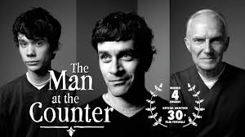

Pre-Discussion:
- What do you think true love is?
- How do people in your family show love to each other?
- What would you do to show someone you love him or her?

Post-Discussion:
- Why did the boy ask about the sugar?
- Do you agree with the boy asking the question about the sugar? Why or why not?
- What emotion did the boy feel after asking the question of the old man?
- How did the story show true love?
- What was the man who was speaking doing at the end of the video?
- Do you think this action was romantic?

